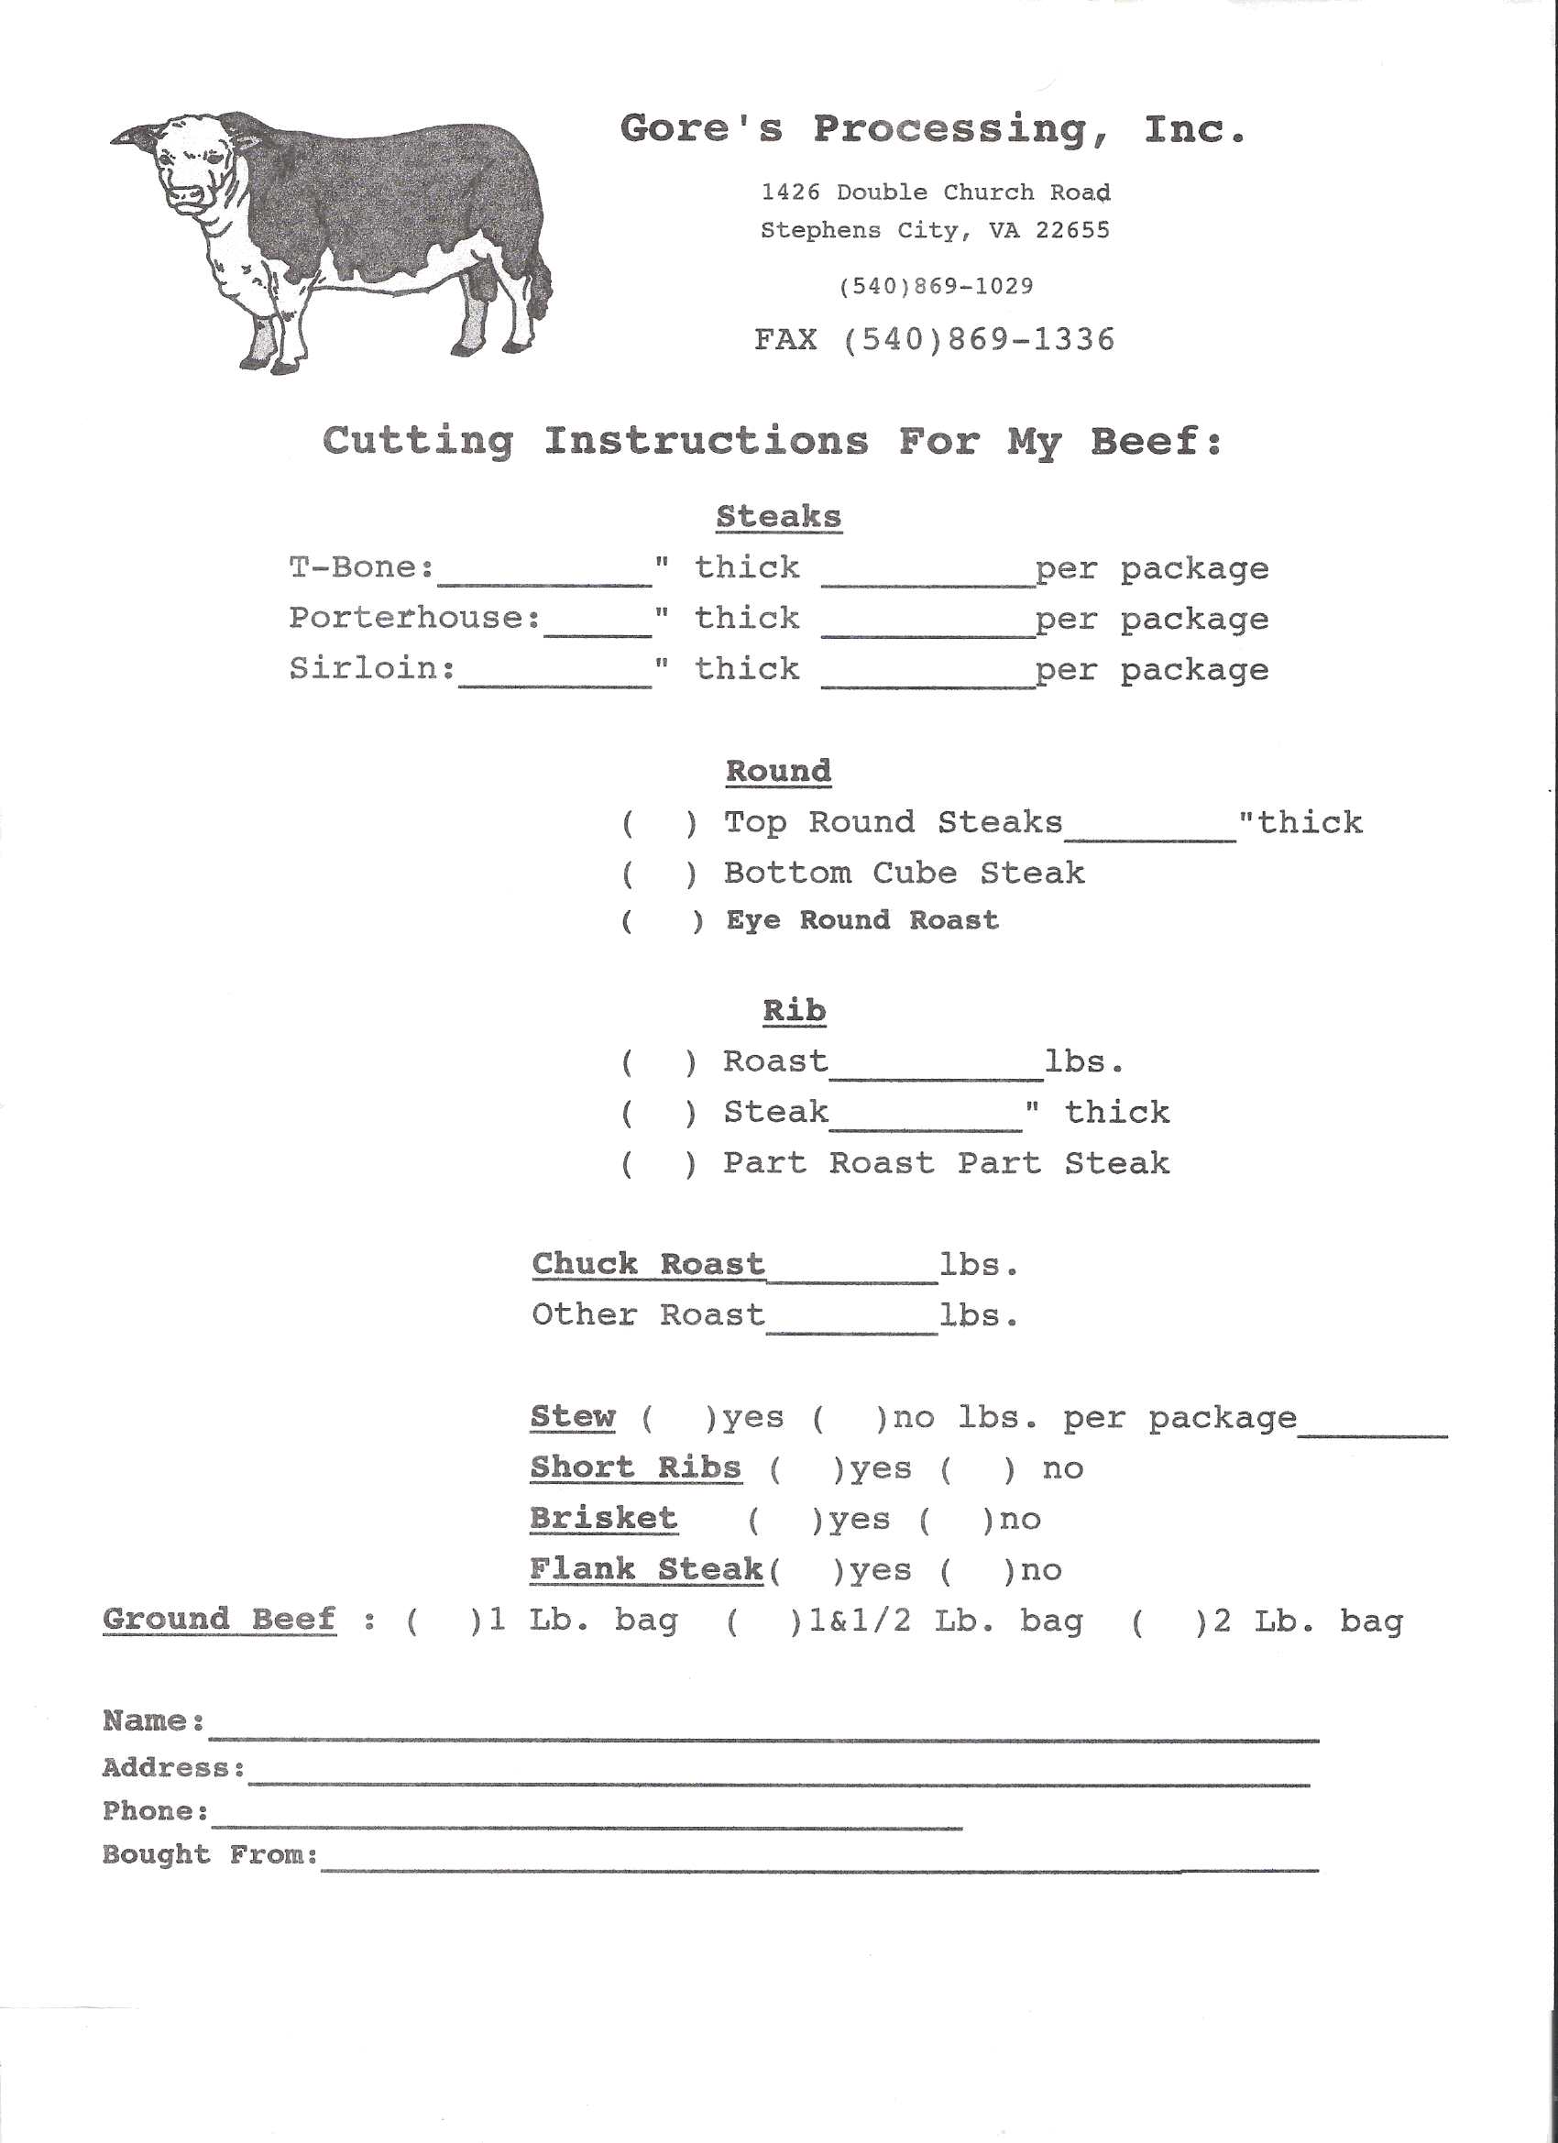
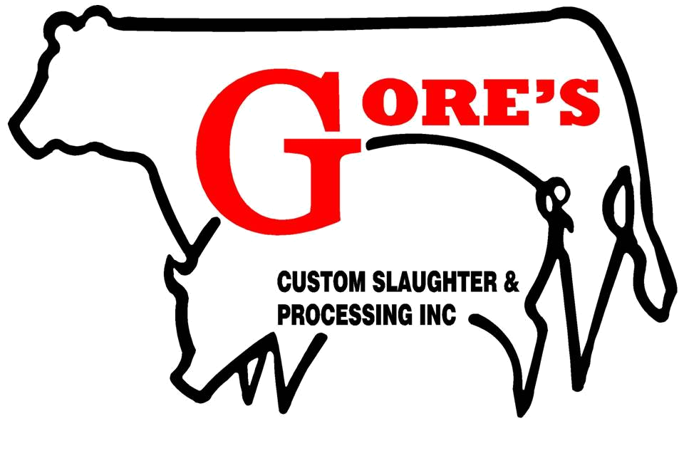
BEEF
( ) 1/4
( ) 1/2
( ) Whole

Directions for Cutting My Beef:

All unchecked cuts will be made into ground beef

Roasts
( ) Chuck Roast ________ lbs.
( ) Other Roast _________ lbs. (Arm Roast, Rump Roast, Sirloin Tip Roast)

Steaks
will be cut ______” thick ________ steaks per package

( ) Rib Steaks

( ) Roast ______ lbs. ( ) Delmonico Steaks
( ) Both roast and steaks

( ) Sirloin always _1_ steak per package

( ) T-Bone ( ) New York Strip
( ) Porterhouse ( ) Fillet

Round
( ) Top Round Steak ( ) London Broil
( ) Bottom Cubed Steak ( ) Bottom Roast
( ) Eye Round Roast

( ) Stew Meat Circle either: 1# 2# Packs Number of packages ____
( ) Short Ribs
( ) Brisket

( ) Flank Steak

Ground Beef ( ) 1 lb. bag ( ) 1 ½ lb. bag ( ) 2 lb. bag

NAME: ____________________________________________________________
PHONE: ___________________________________________________________
ADDRESS: _________________________________________________________
EMAIL: ____________________________________________________________
BOUGHT FROM: ___________________________________________________

